Flutter Developer Bootcamp

Signup Screen

Workshop #01

# **Purpose**

This workshop demonstrates how to create a sign-up screen where the user can register themselves by providing their data.

# **Problem**

In your Flutter app, you're building a user registration application. You want to create two input fields: one for a phone number and another for a password.

* For the phone number field, you need to ensure the following:

1. Users can only input 10-digit numbers.
2. The keyboard type should be restricted to numeric input.

* The password field should be a standard password input field.

# **How to Solve**

1. Checkout the workshop from Git Repo:

git clone -b <user-branch> <repo-URL>

2. Open the root folder inside VS Code

3. To build the app click the run option in the main method { }

4. Create the two input field what we mention in the problem

# **You Will Achieve**

In this workshop, you will learn how to create a signup screen using Flutter. By completing this tutorial, you'll gain hands-on experience in building user interfaces with essential components such as images, text fields, and buttons.

# **Screenshots**

## **Before implementation (without Phone Number & password)**

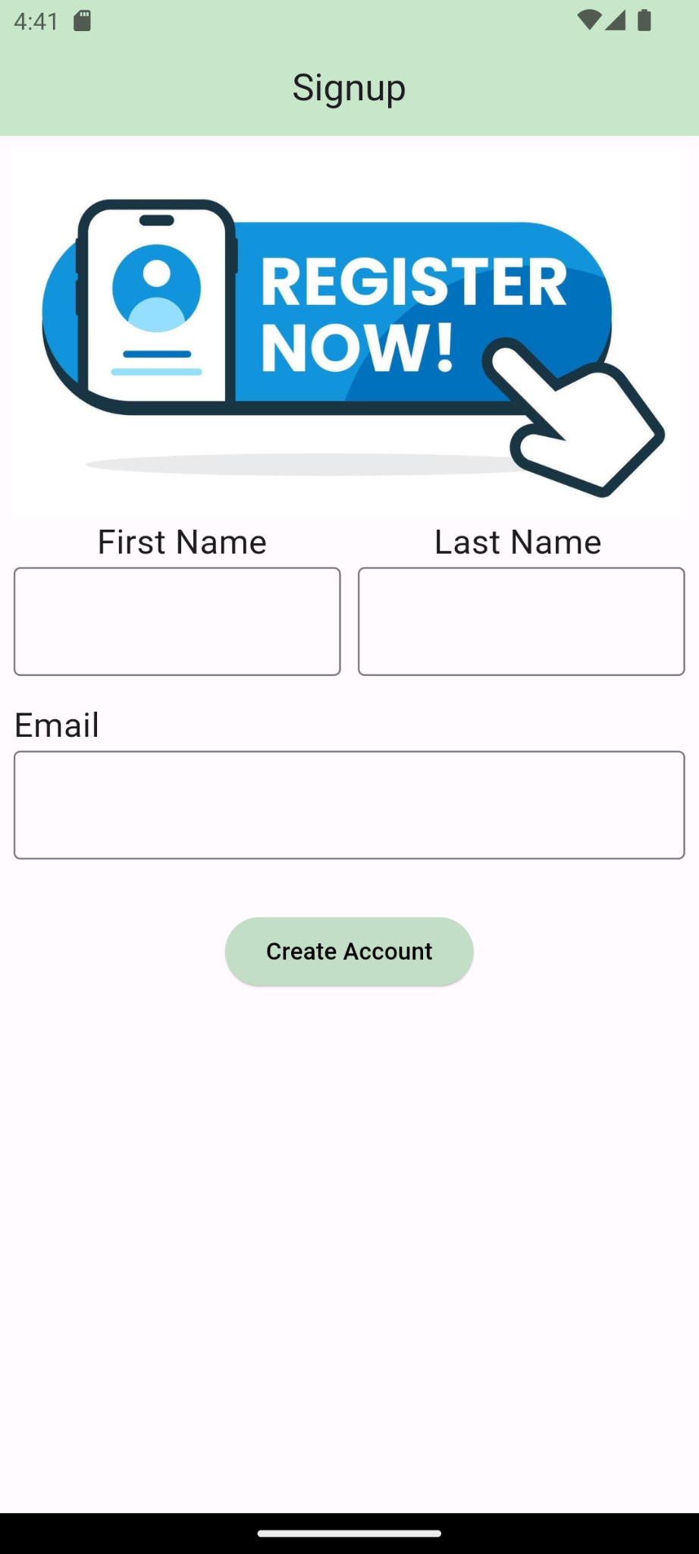

## **After implementation (With Phone Number & password)**

## 

# **How to submit your workshop**

Push your project back to the same git branch using command:

<command name>

# **Happy Coding!**